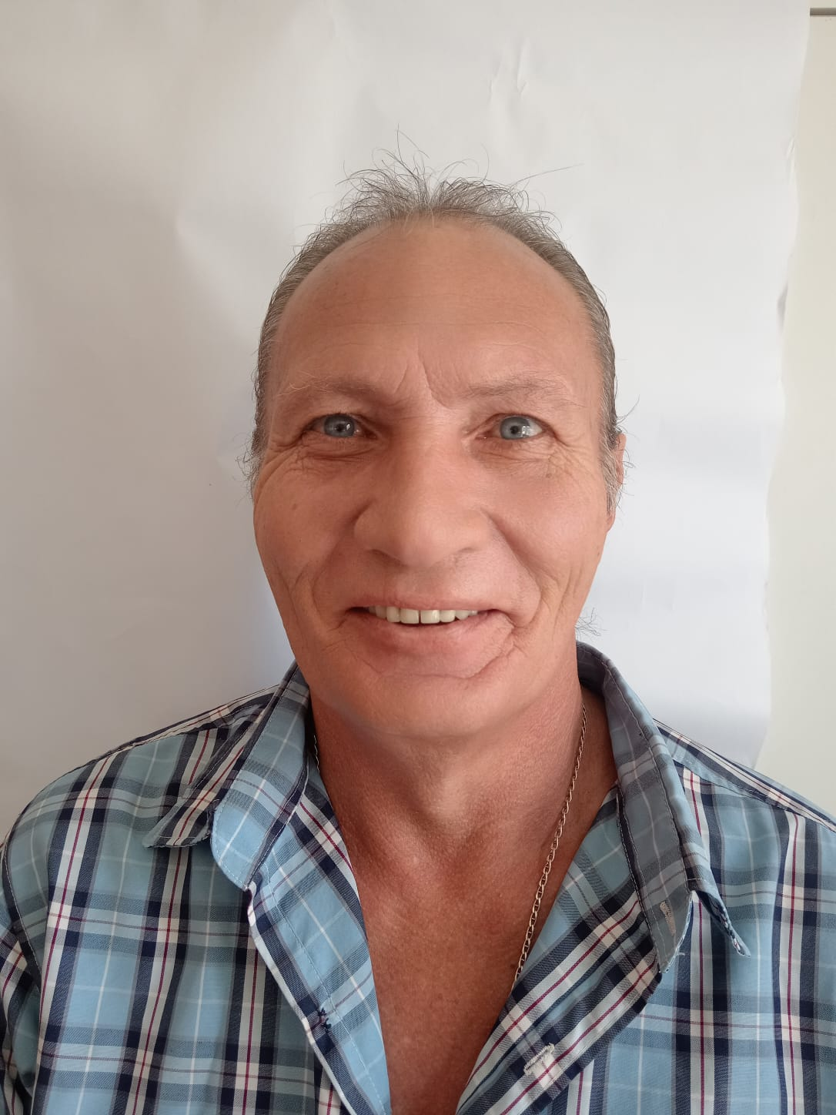  Profile  Accomplished H2A seasonal work at Keystone Cooperative in Ohio 2023-2024, adapt in leveraging skills for organizational benefit. Healthy, energetic and disciplined. I’m a hard worker and I embody motivation, reliability and punctuality. With keen attention to detail. I’m adaptable, learning new skills easily. A bilingual team player and or independent worker. I excel in analytical and interpersonal tasks. Eager to contribute to any team  Contact  PHONE:  +27 81 776 2414  Whatsapp:  +27 81 776 2414  EMAIL:  Schalkwpieterse@gmail.com  Personal details  ID NO: 641014 5132 085  Date of Birth 14/10/1964  Nationality: South African  Marital status: Married  Valid Passport: Yes (until 2033)  Visa status: Never denied a Visa  Social security: Yes  USA Drivers license: YES  Hobbies  Gardening  Reading  Watching movies  Maintenance around the house  REFERENCES  Kreg Albers (Keystone Cooperative)  +19374177398  Barbara Rosta (Metrorail)  +27 217745532  SKILLS |  | Schalk WILLEm PIETERSE  EDUCATION  DF Malan High School  January 1978 – December 1980  Training  Advance truck driving 2001  Train drivers diploma 2009  Propane handling filling, storage and transporting : 2023  Forklift training :2023  Certified Trucker against human trafficking: 2023  Core Exams (wet and dry fertilizer: 2023  PPE 2023  WORK EXPERIENCE  Keystone cooperative Agriculture Equipment operator  April 2023 – December 2024  Duties:  - Main duties were mixing and distributing of wet and dry fertilizer and chemicals to farms for spraying,  - ground sampling,  - maintenance of building and equipment.  - Service and repairs of vehicles.  - Building fertilizer bins, storage areas and sheds.  - Propane filling and handling.  - I can use electric equipment (Drill, skill saws, etc.)  - Excellent experience in heavy-duty truck driving, weighing trucks on the way bridge.  - Filling and handling propane tanks  - General farm labour including fertilizing, planting, cultivating, and harvesting crops. Prepare farm  - grounds and equipment for the planting season. Set, operate, and maintain farming equipment  - to plant, fertilize, and harvest crops. Use power equipment, including tractors, ATVs, UTVs, and  - associated implements. Complete general farming duties such as servicing equipment, shop  - work, loading and unloading materials, and maintenance of farm grounds and equipment.  Metrorail Train driver  Jan 1981 – March 2023  - Planned maintenance.  - Overall responsible for a train driver.  - Driver Training practical and theory  - Responsible of a train driver  - Inductions and on-route training  - Ongoing refresher training with existing drivers  - Weekly feedback to management  - Driver stats regarding consumption and incidents

