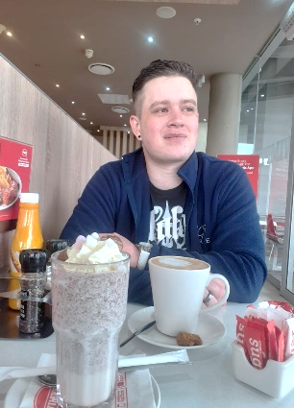
]
Contact
Education
064 368 9687
Phone
cornelesend@gmail.com
Email
139
Carlyle Avenue Orkney

Address
David Cornelesen

I am a passionate and hard-working person; I strive to do my best and obtain perfection in what I
do. I am a driven and Ambitious individual who always completes a task to the best of my ability.
I like to be organised and can create and structure systems immaculately. I am a team-oriented
worker but at the same time I can work independently from others. I believe that in whatever I do, I go above and beyond to be a step above the rest.

Experience
Learned how to be calm under pressure and provide excellent customer service. Mastering how to handle challenging consumers and stressful situations as well as acquired highly effective bilingual communication abilities for bargaining and persuasion.

Delegating visitor reception and accurately recording visitor information, Managing the safety messieurs implemented by the Department of Education, assisting with administrative tasks and the supervision of students when teachers are unavailable and executing daily tasks with pinpoint accuracy.
I enrolled in the church internship program with the intention of growing spiritually, and in the process, I learned a lot of useful skills. I gained knowledge of social media management, the fundamentals of digital marketing, post design, announcement slide design, and commercials. In our Sunday School and Youth Group, I gained experience working with people of all ages and even dealing with challenging individuals. I also learned how to inspire and oversee a sizable group of kids and teenagers. I developed the ability to follow specific instructions when it comes to taking orders and completing tasks, particularly when it comes to event organizing.

Sales Assistant
Covid-19 Officer
Intern | General worker
March 2021 – September 2023
May 2020 – February 2021
January 2019 – December 2019
Crafters Corner
Laerskool Noordvaal Primary
AGS Orkney
083 272 6207
-
Jannie Swanepoel
Phone:

Email :
Crafters Corner | Owner
074 256 2675
lootbasson@gmail.com
Lodewyk Basson
Phone:

Email :
Youth Leader | Worship Leader
Reference

- Afrikaans (Home Language)
- English (First Additional)
- Pure Math
- Consumer studies
- Computer applications technology
- Life sciences
Grade 12
2018
Skilled at Microsoft Word, Excel and PowerPoint.
I am a very disciplined and persistent individual.
I have a vast knowledge of computers and applications.
Skill Development
English
Afrikaans
Expertise
Language

