Website
Linkedin API fills CV information; do we need a plug in what options and at what price?
https://lix-it.com/pages/linkedin-api#pricing

Will the above autofill customers job personal data and extract profile information to autofill parts of build cv?
As I have checked the LinkedIn paid API we will on gather this information from API. We have just free 10 credit for 10 API calls.
- First Name
- Last Name
- Location
- Current and Previous Year Experience
- Job Title
- Start Date
- End Date
- Location
- Organization
- Certification
- skills

Pricing Plan for API:
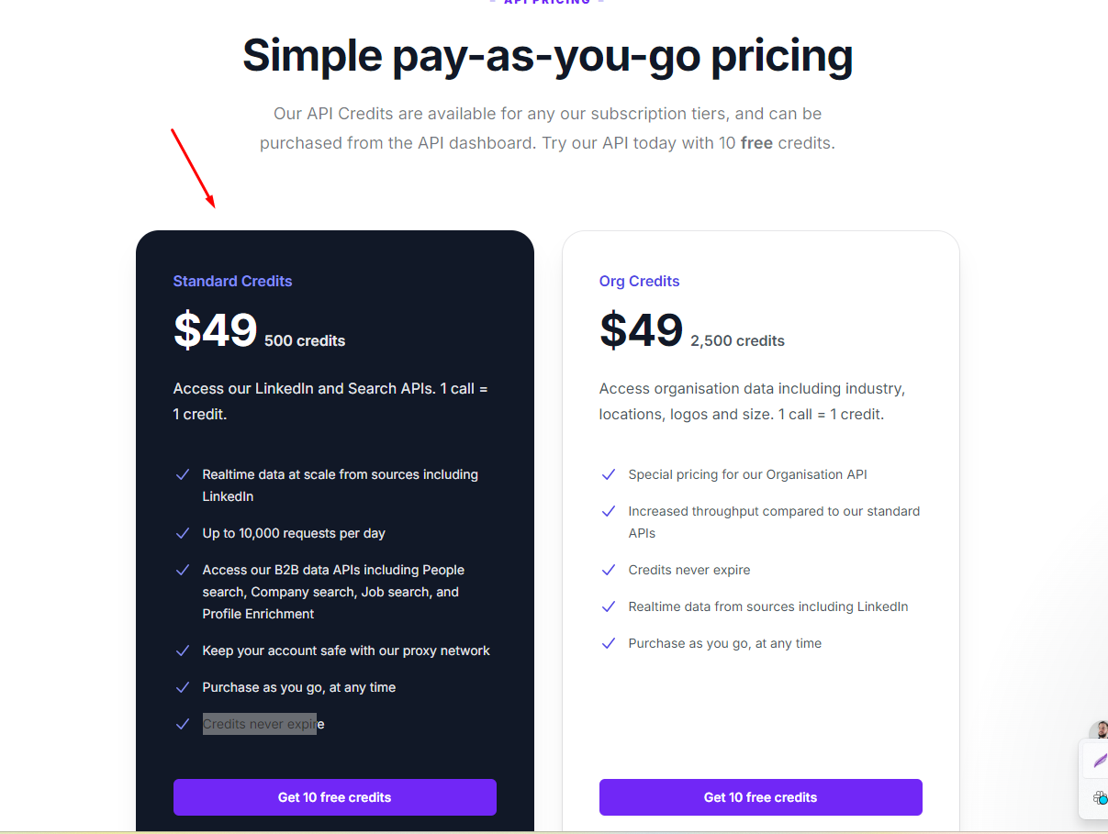

Google & Linkedin log in / create account functionality
https://wordpress.org/plugins/nextend-facebook-connect/
Do you need

Move hosting ( need cost )
- What do I need to message to current hosting provider what does he have to do?
- Change to adareocareers.com
- We own domain and have email set up
- Need to connect new email for account set up automation
1. We need Domain Detail and Current Hosting Provider Detail In which the website is currently Hosted.
2. If you are planning to hosted the website to new Hosting platform then we also need that Hosting plan service Detail.

Time Taken : 10-12 hrs

Change copywriting to word document that will follow on homepage and page when click advance career - https://adareo.com/cv-page/

Need Confirmation from Sandeep Sir end

Add google reviews widget ( will give access to google my business profile ) I use free plug in on shopify is there a free wordpress plug in that will look like this?
https://www.youtube.com/watch?v=NdfnzLv8Eg8
https://wordpress.org/plugins/widget-google-reviews/
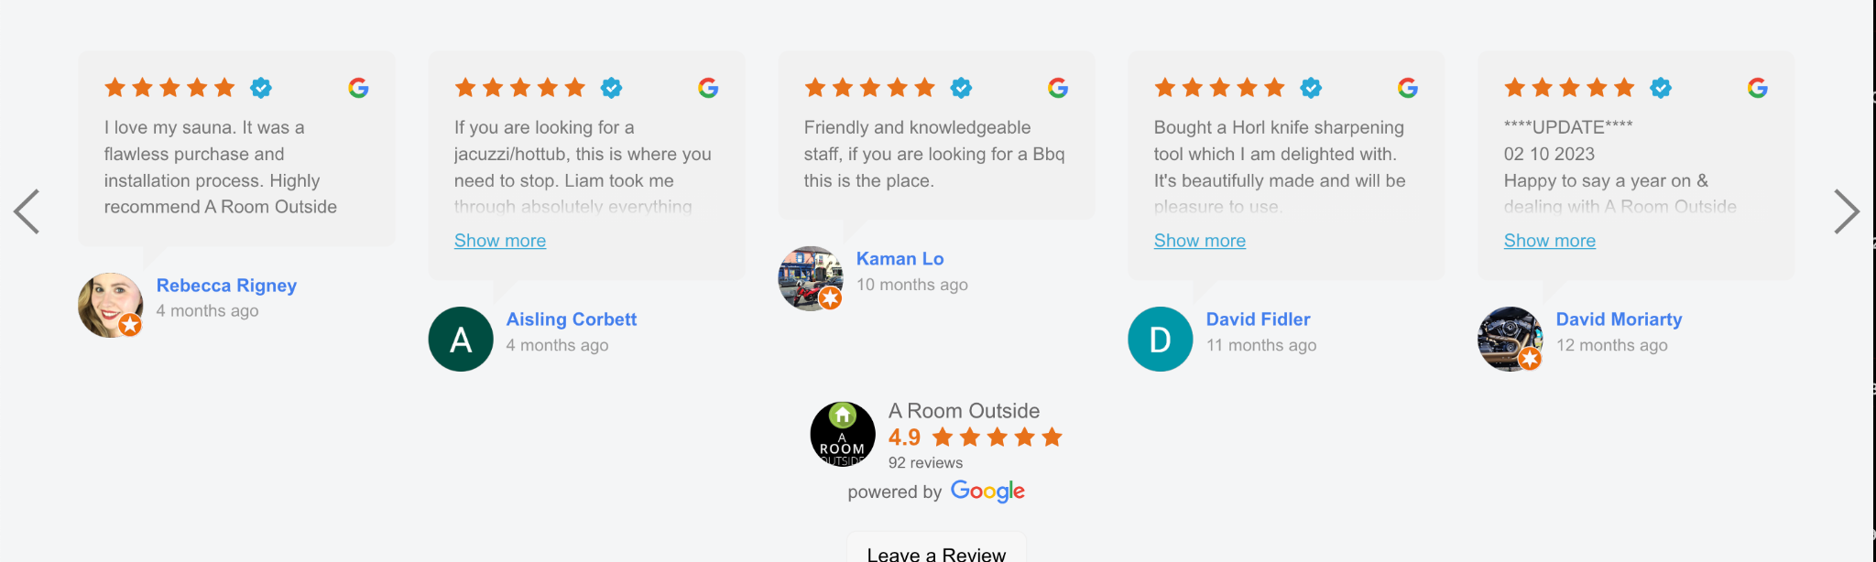

Integrate Trust pilot and do same with widget when account fully set up, will discuss where to put both things

https://support.trustpilot.com/hc/en-us/articles/360011086320-Install-Trustpilot-s-WordPress-integration
https://wordpress.org/plugins/better-business-reviews/

